NAME \ BASMA MOHEY EL-DIEN MAHMOUD SLIEM

B.N \ 14

SECTION \ 11

TOPIC \ PROGRAMING LANGUAGES

APPLICATION BRIEF \ I have chosen programming languages because they are the most important to learn lately.

And it is interesting for me to enter the world of programming through this project. I learned several languages, including \ java .javascript .c++ and c.

The reason for the difference in languages is only the ease of obtaining results.

The reason why I chose these four languages is because of their popularity among the rest of the languages.

Screenshots \ 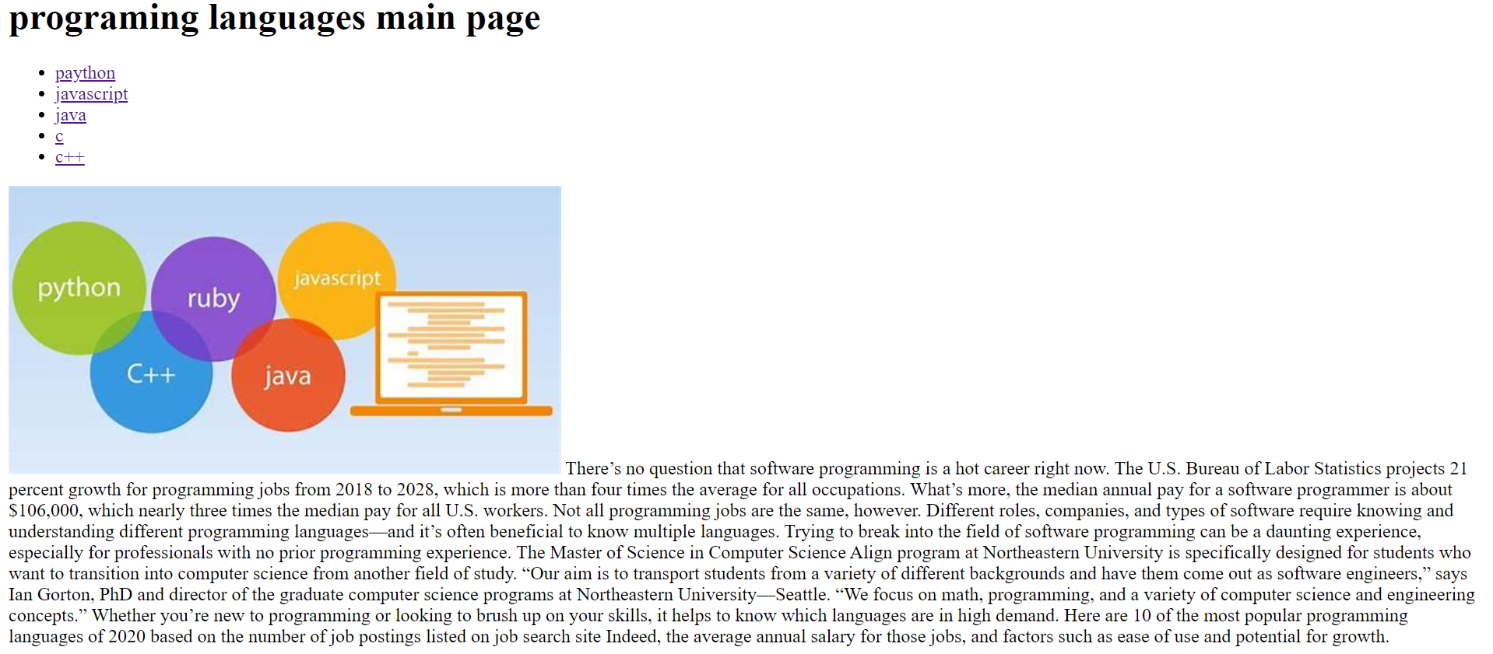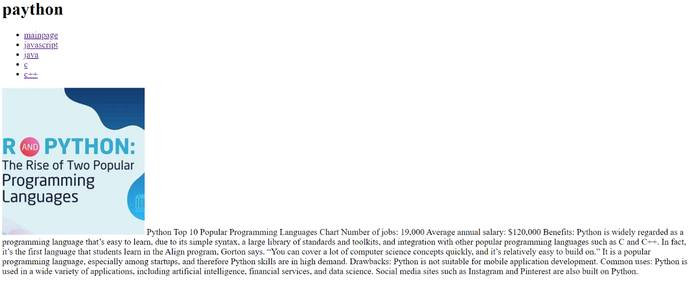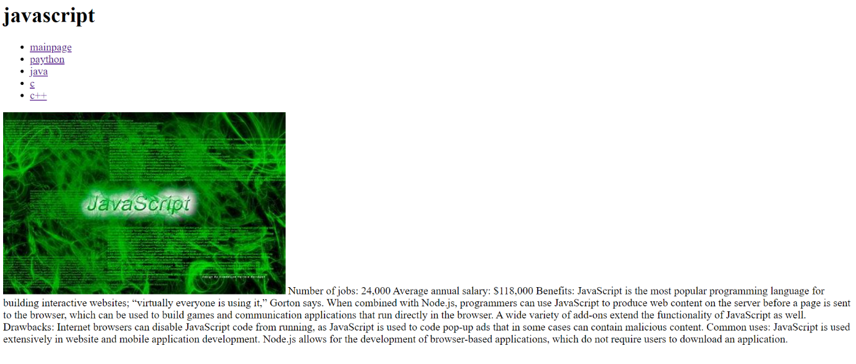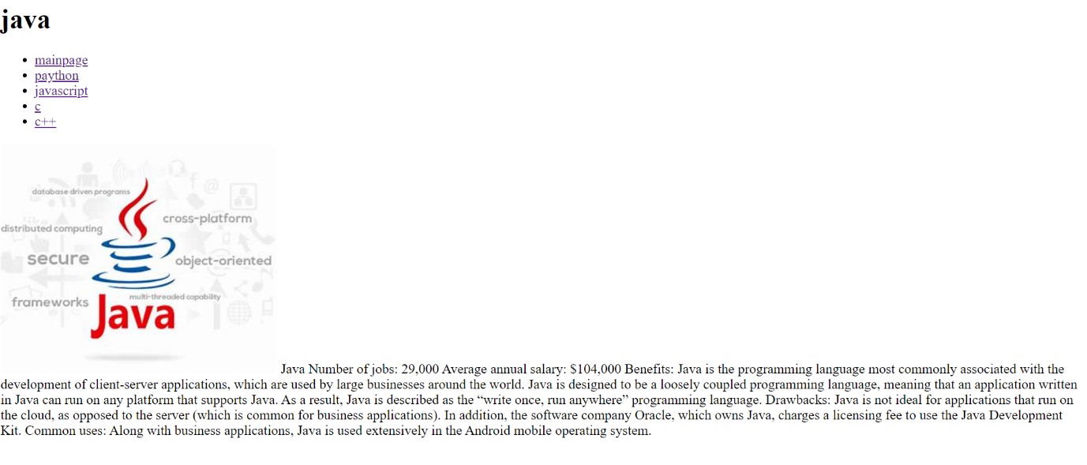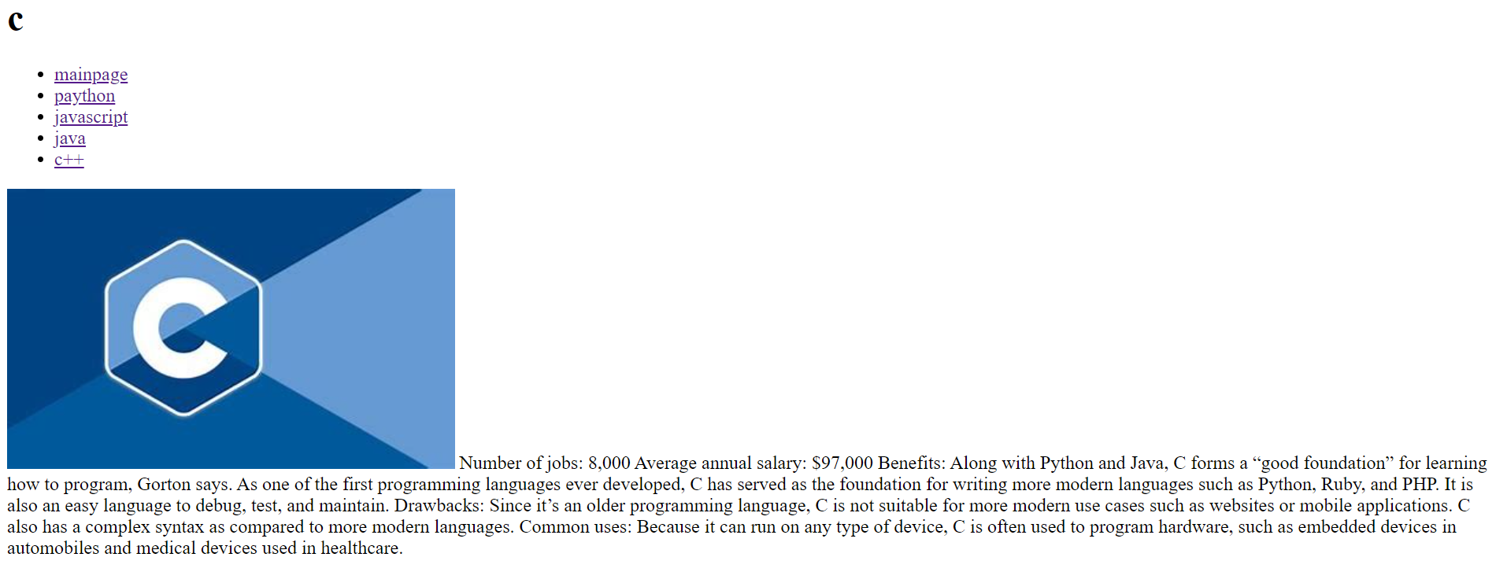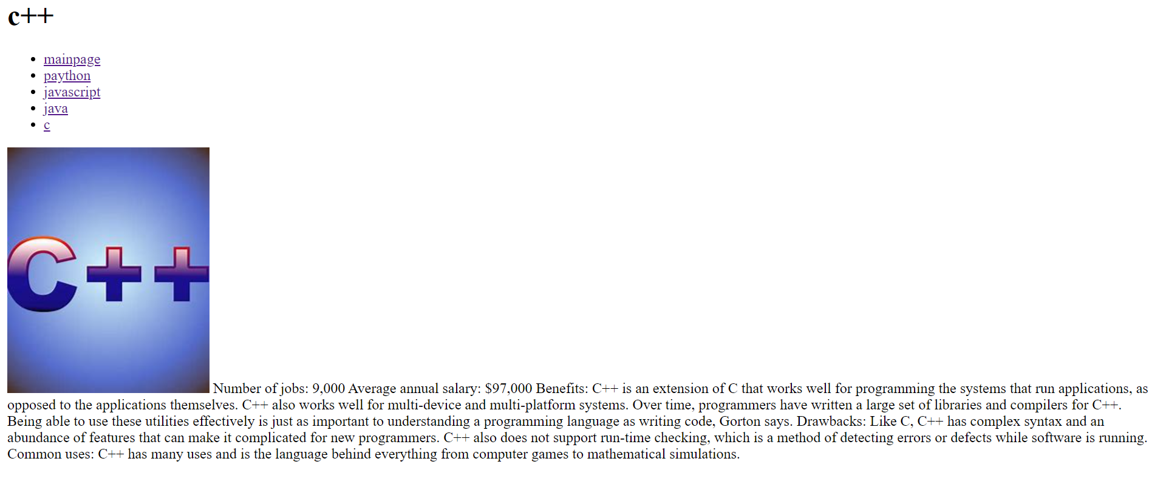

SOURCE CODE \ 